## Go to the AWS EC2 Console:

In the AWS Console, select the “Oregon” Region, select “EC2” and select “Security Groups” from the left-hand navigation bar, then click “Create Security Group”: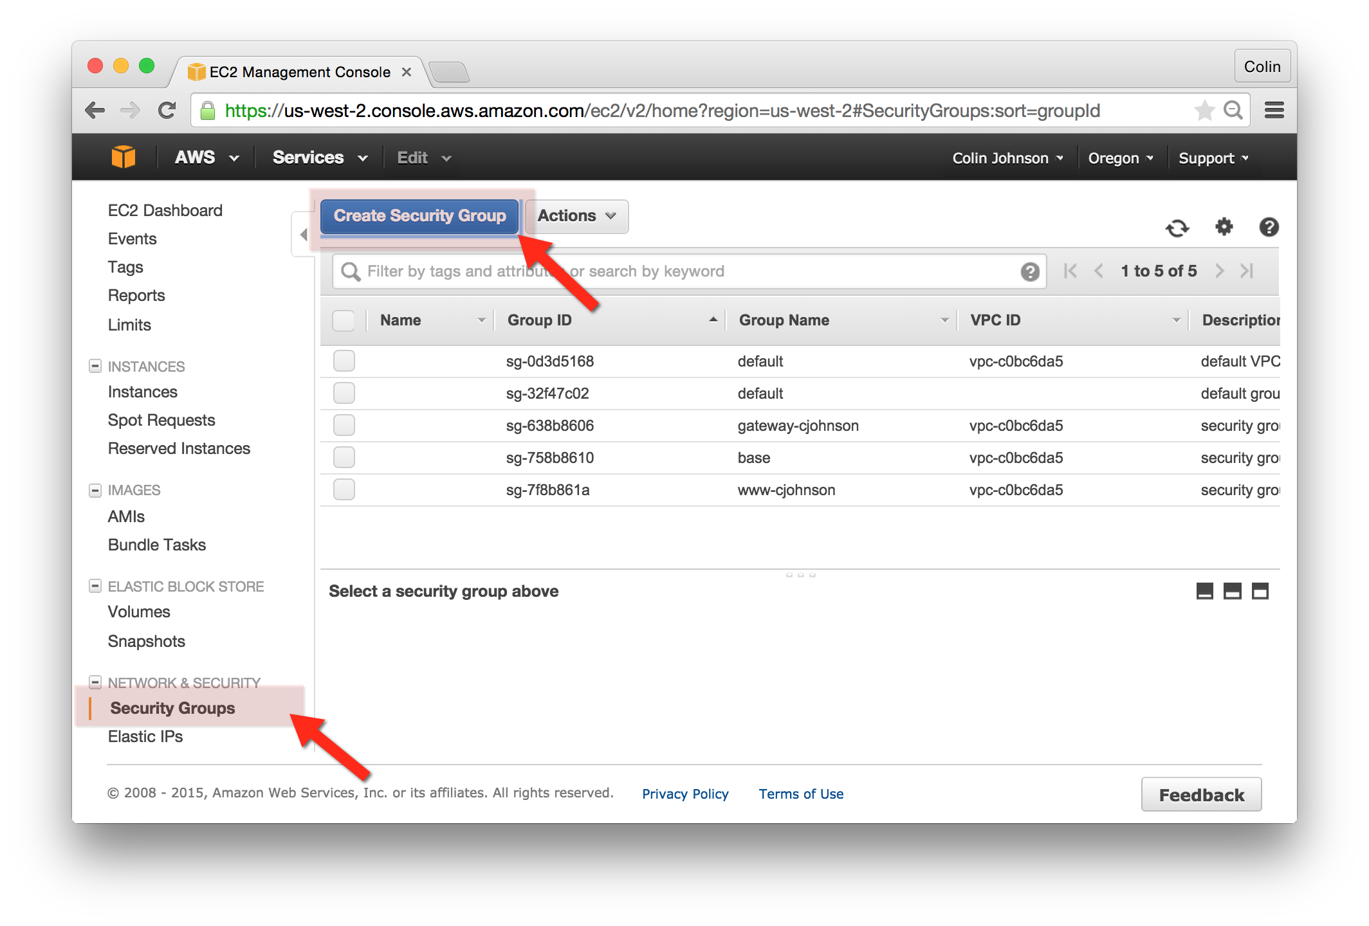

## Create an www ELB Security Group:

Create a new Security Group, as follows:

* Security Group Name: www-elb-yourname
* Description: www-elb-yourname
* Inbound Rule:
  + Type: HTTP
  + Protocol: TCP
  + Port Range: 80
  + Source: Anywhere

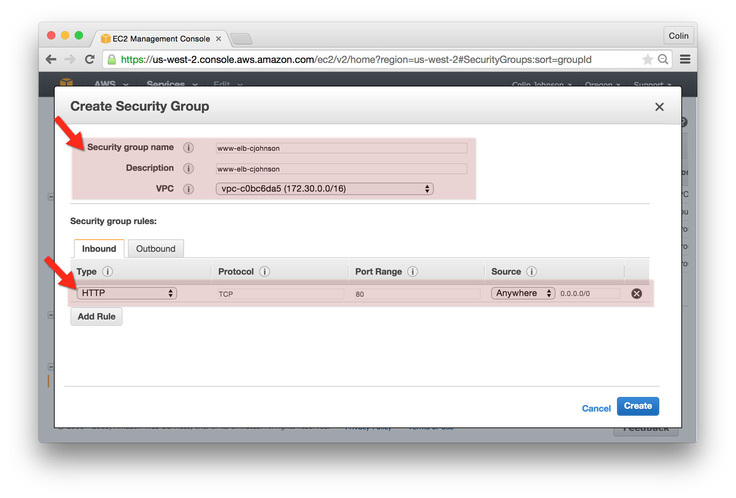

## Modify the Existing www-yourname Server Security Group:

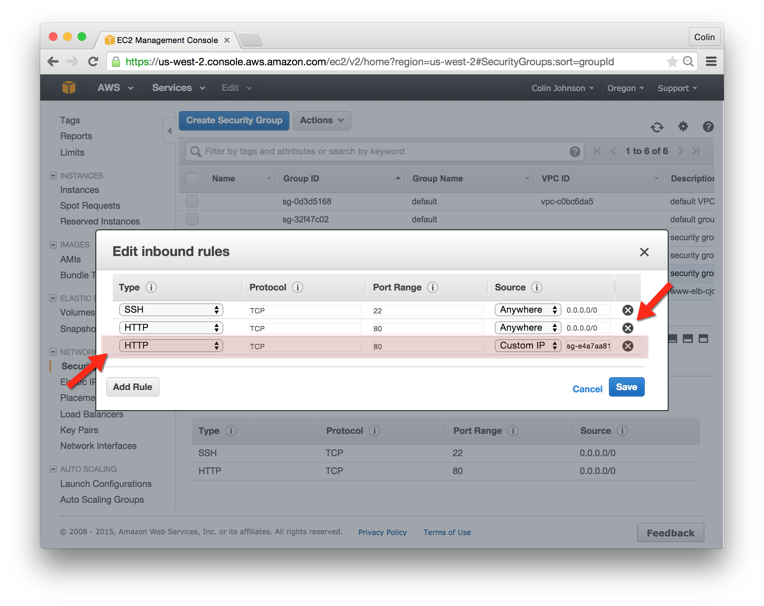

* Select the www-yourname Security Group
* Click the “Inbound” tab and select “Edit”
* Add a Rule, as Follows:
  + Type: HTTP
  + Protocol: TCP
  + Port: 80
  + Source: www-elb-yourname
* Remove the existing HTTP/Anywhere rule

## Create a www Elastic Load Balancer:

**Configure Your Load Balancer:**

* Load Balancer name: www-yourname
* Create LB Inside: choose the “default” VPC
* Create an internal load balancer: not selected
* Listener Configuration, setup as follows:
  1. Load Balancer Protocol: HTTP
  2. Load Balancer Port: 80
  3. Instance Protocol: HTTP
  4. Instance Port: 80
* Select Subnets:
  1. Select all Subnets

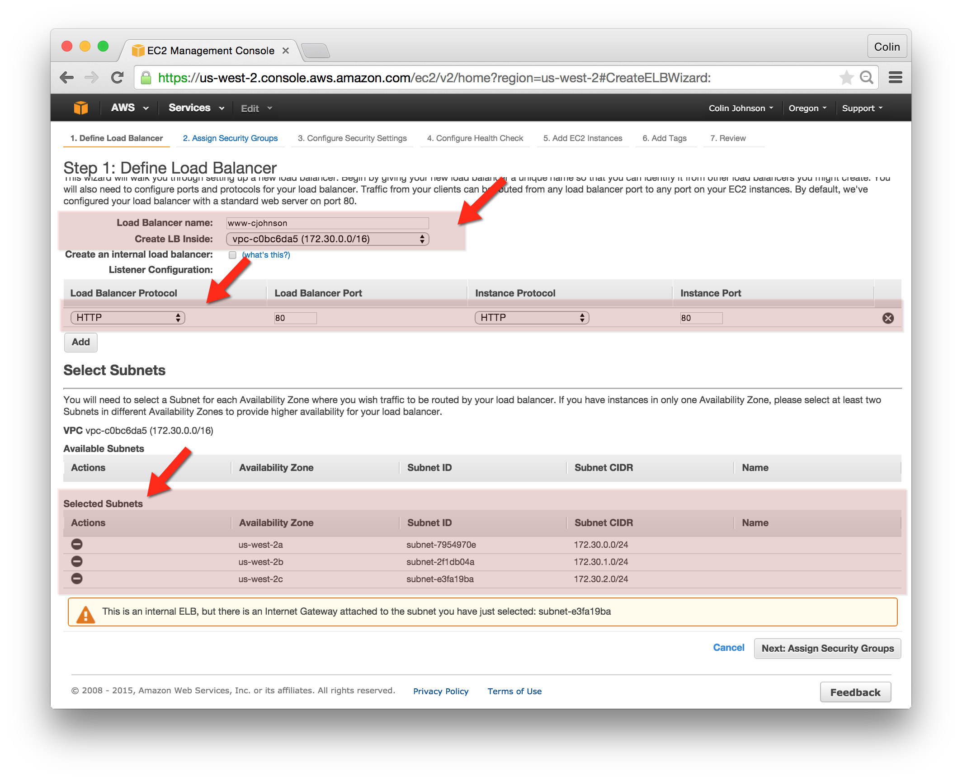

**Assign Security Groups:**

* Choose the www-elb-yourname Security Group

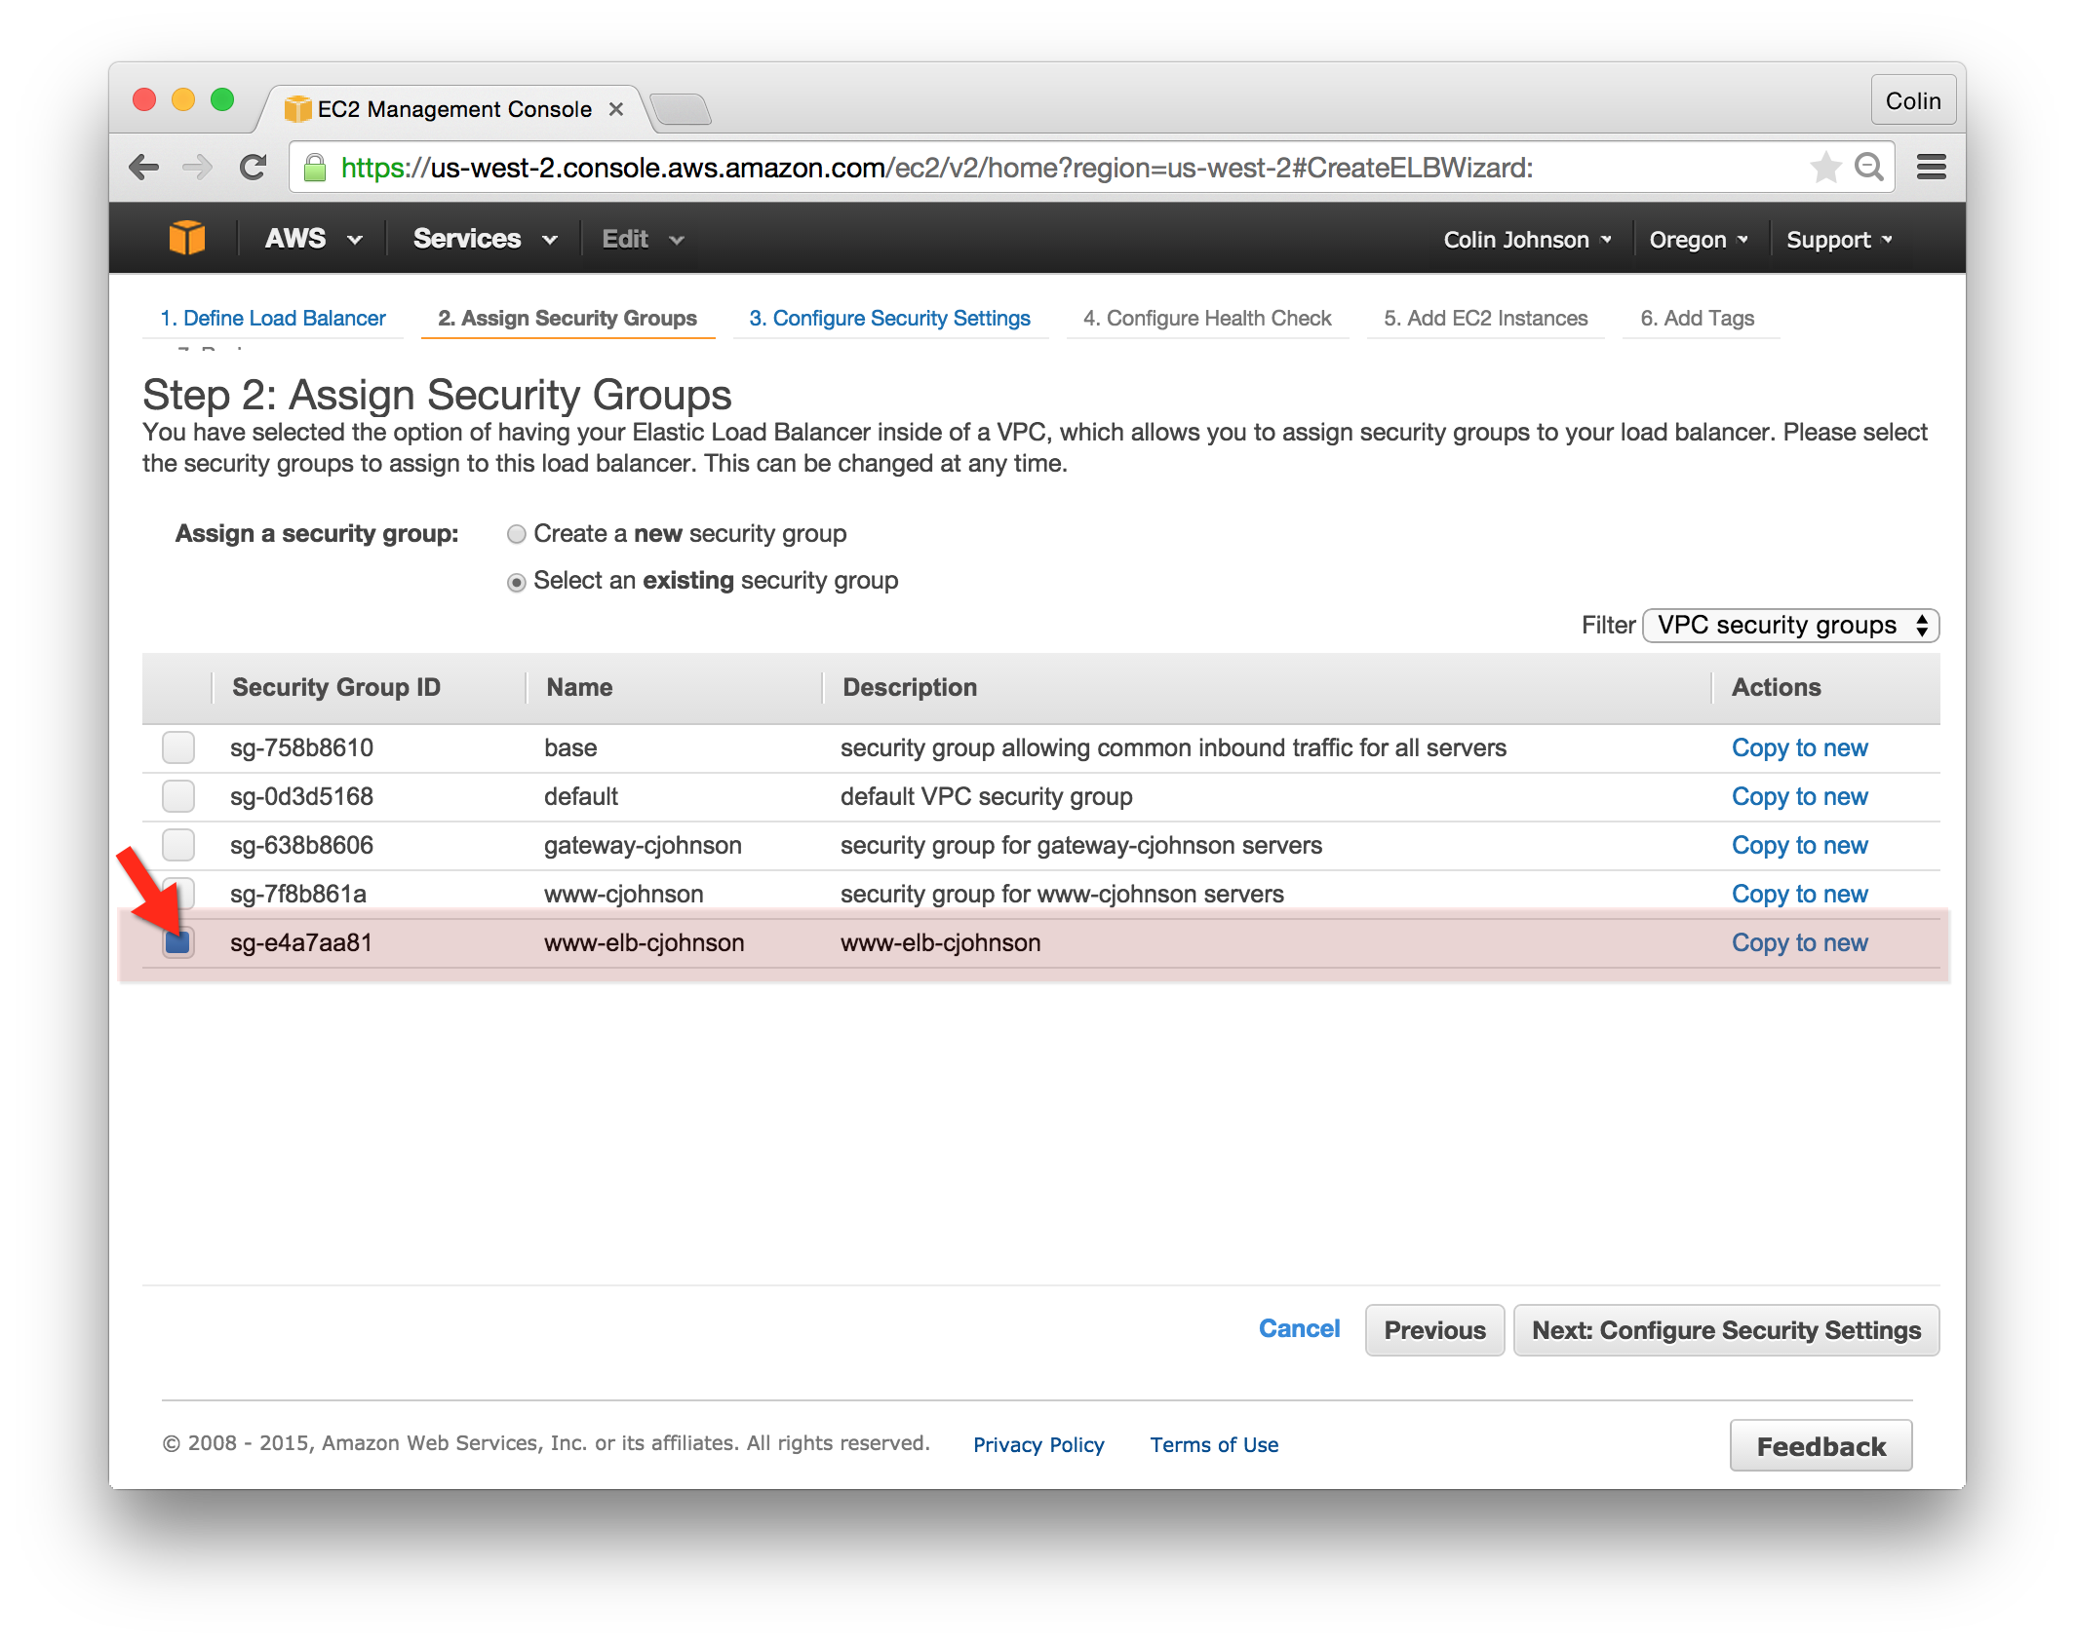

**Configure Health Check:**

* Ping Protocol: HTTP
* Ping Port: 80
* Ping Path: /index.html
* Advanced Details: leave as is.

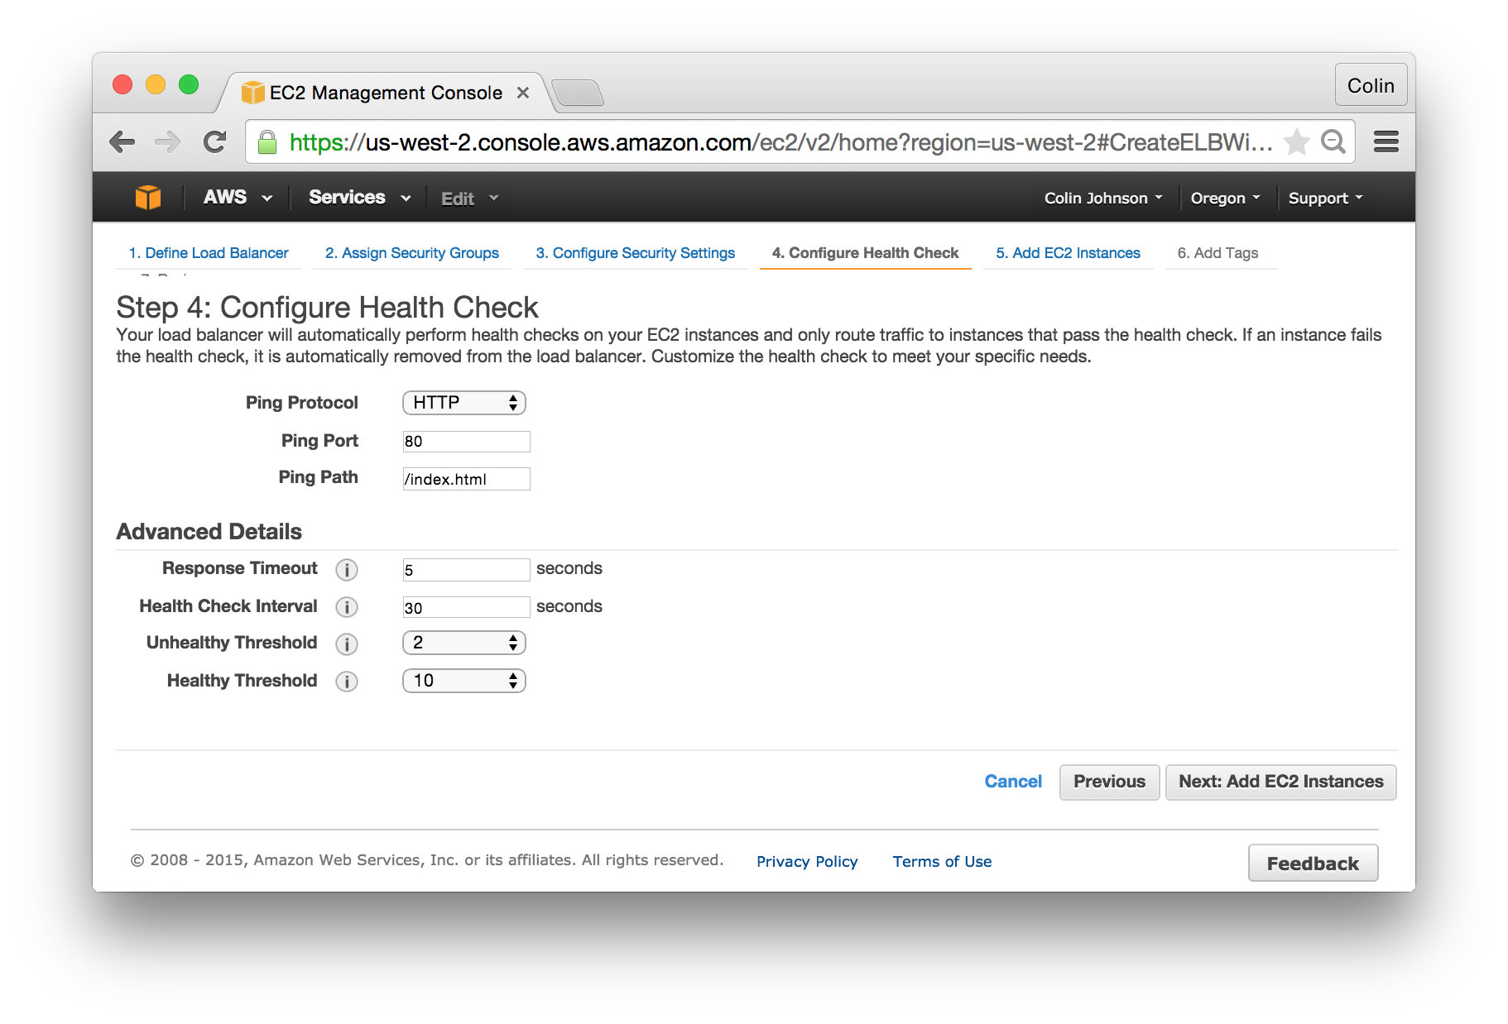

**Add EC2 Instances**

* Add EC2 Instances:
  + Add the www-youname Instance
* Availability Zone Distribution:
  + Enable Cross-Zone Load Balancing: checked
  + Enable Connection Draining: checked
* Click “Next: Add Tags”

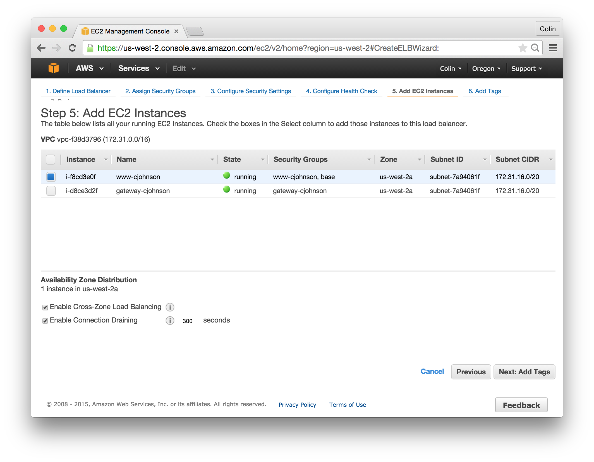

**Add Tags:**

* Create a Tag as Follows: “Name=www-elb-yourname”
* Click “Review and Create”

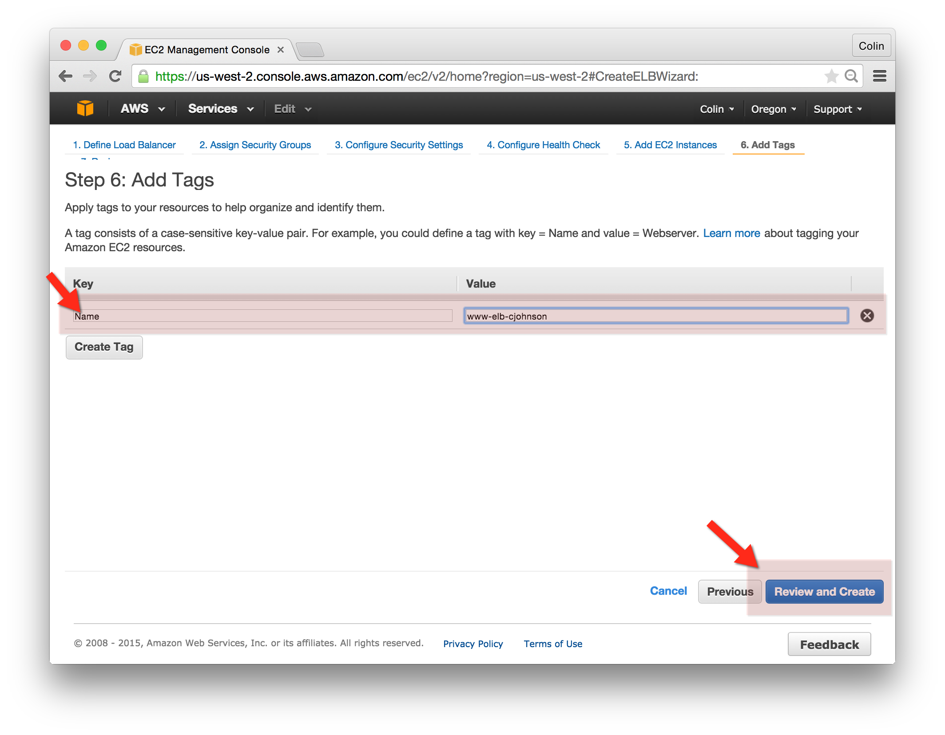

**Review:**

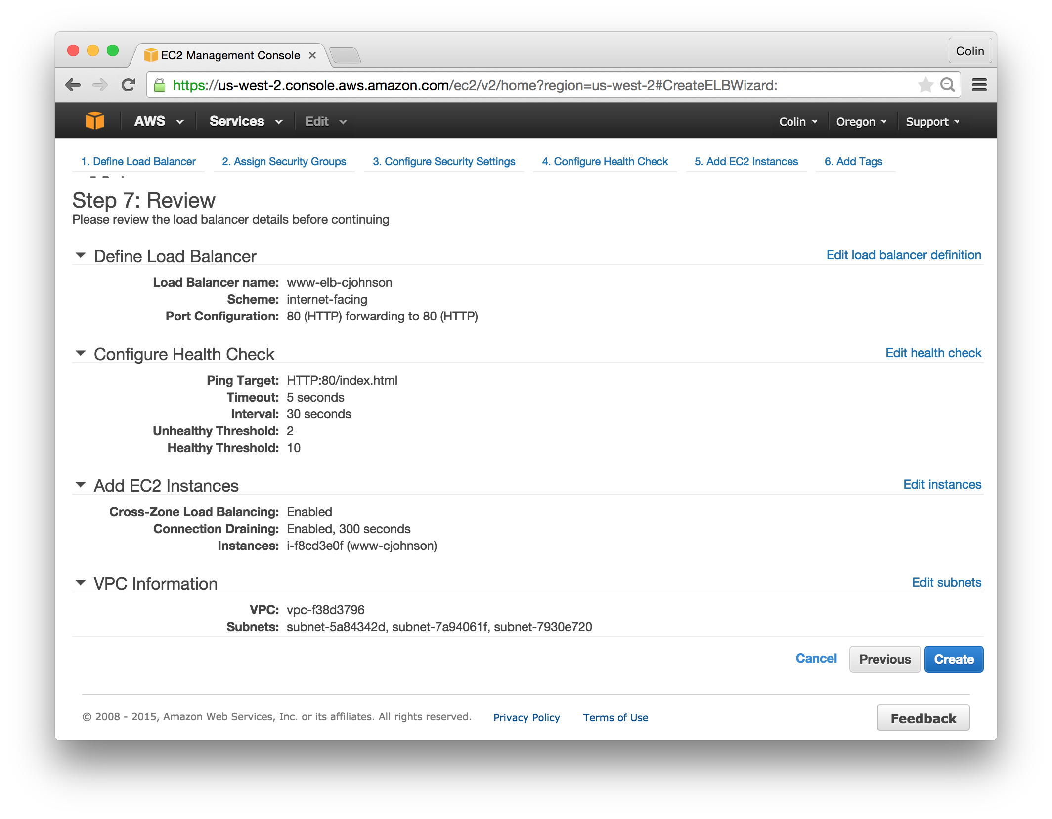

## Confirm Load Balancer Built and Instance Placed in Service!

After clicking “Complete”, return the the “Load Balancer” service page in the AWS EC2 Console and confirm that your www-yourname EC2 Instance is in service. An example is below:

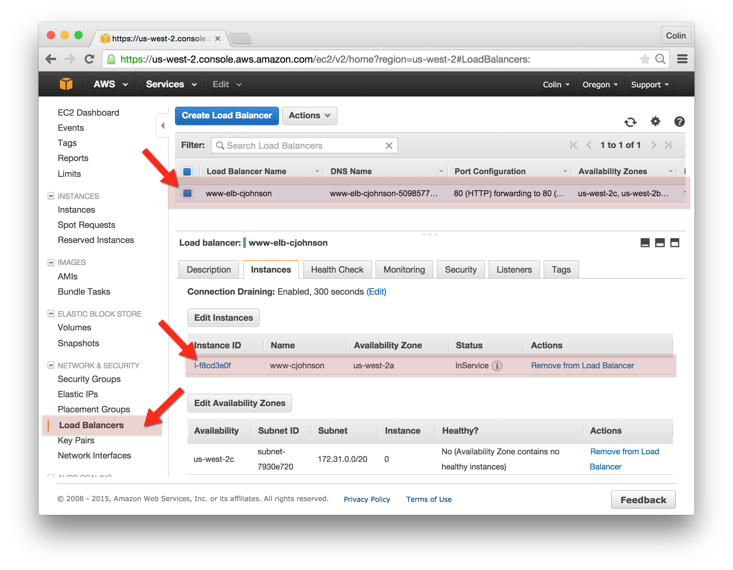

## Lastly, request a page through the Elastic Load Balancer:

* Select your www-elb-yourname Load Balancer from the EC2 AWS Console
* Click the “Description” tab and select the DNS Name
* Paste this DNS name into your web browser – this request should be directed to your back-end instance.

